Name: | ___________________________________________________ |  | Date: ___________
 | Year 10 Pre-Stage 2 and 3  In – Class Component  QUADRATIC FUNCTIONS – SOLVING EQUATIONS |  | 37  = %
Total Time: | 55 minutes | Penalties (only deducted once in the whole assessment):   Rounding - Incorrect/inappropriate (-1)   Notation – incorrect/missing (-1)   Units - Incorrect/missing (-1)
Weighting: | _0___% of the year.
Equipment: | Scientific calculator and CAS calculator
Important Information:

Important Information:
Although the take-home component is not worth any marks, it is essential in preparation for the in-class component. Knowledge and skills gained will be extended in the in-class validation component. This in-class validation will be completed under test conditions on the day in which this take-home component is due. The take-home component may be used when completing the in-class component. Contact may be made to parent(s) if the take-home component is not available for submission (at the start of the lesson).

AIM: To review factorising quadratic functions and expanding and to understand how to solve the quadratic functions using different methods i.e. graphing and using CAS.

 | This Investigation is based on the take – home component. Please read each of the problems carefully before work on any of the tasks below.
Task 1 | When a number is subtracted from its square, the result is 72. Find the number.  [ 10 marks: 1, 2, 2, 2, 2, 1]
 | a) Write the unknown quantity algebraically
b) Write down the information you have been given. (You may need to draw a diagram sometimes).
Write an equation from the information. Expand and simplify the expression (rearrange to make the equation equals zero).
 | c) Factorise the equation. Or set up the equation so you can use the Null Factor Law.
 | d) Solve the equation using Null Factor Law.
 | e) Does your solution/(s) seem reasonable? (Yes or No) and why?
 | f) Write down your solution in words.
Task 2 | AGE FACTOR!  Square of Jamie’s age now is equal to his age in 6 years time. How old is Jamie now?  Use the method in task 1 to solve the problem step by step.  [9 marks]
Task 3 | Investigate Quadratic function using Graphing Techniques
Solve the following function
y = x² + 2x – 3
[10 marks: 6, 2, 1, 1]
- Complete the following table:
x | x² | 2x | -3 | y = x² + 2x – 3
-4 | (-4) ² = 16 | 2 x (-4) = -8 | -3 | y = 16 + (- 4) -3 y = 9
-3
-2
-1
0
1
2

- Draw the graph represented in the above table:
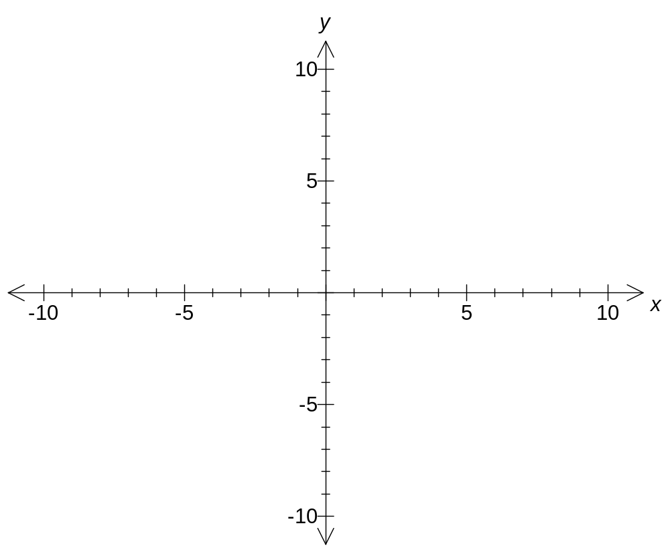

- Where does the graph intersect the x axis?

- Given that the solution(s) of an equation are the points where the graph of the equation cuts the x axis, what is the solution of x² + 2x – 3 = 0?

Task 4 | Investigate Quadratics using TI CAS calculator.
A ball is thrown upwards and reaches a height of h meters after t seconds as given by
h = 16t – 4t²
Find the time when the ball is on the ground.
[2 marks: 1, 1]
 | Method 1 – By analysing the graph in the Calculator
(follow the instruction on the CAS calculator)

1. Add graphs to your calculator.
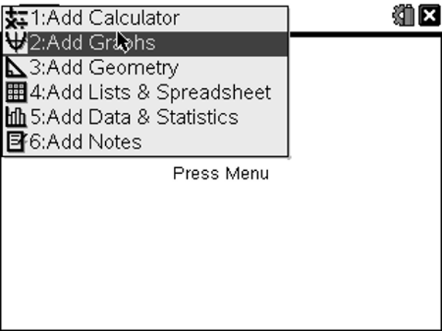

2. Fill the information for f1(x) at the bottom of the graph page with 16x – 4x²

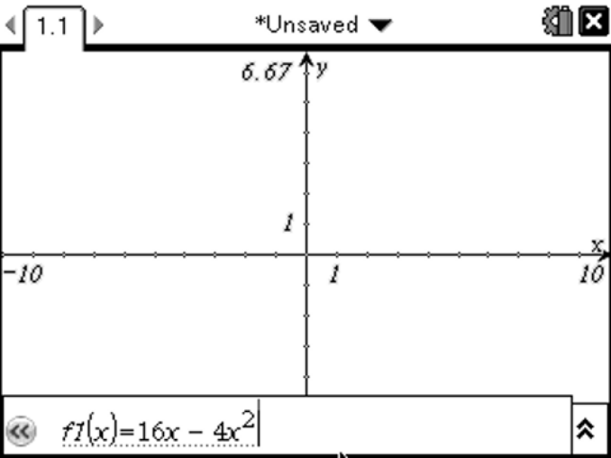

Note : you will not use ‘t’ rather use ‘x’ for the calculator.

3. Press enter to get the graph.
Once you get the graph, go to menu press trace then graph trace and trace the parabola to find where the graph cuts x-axis at.

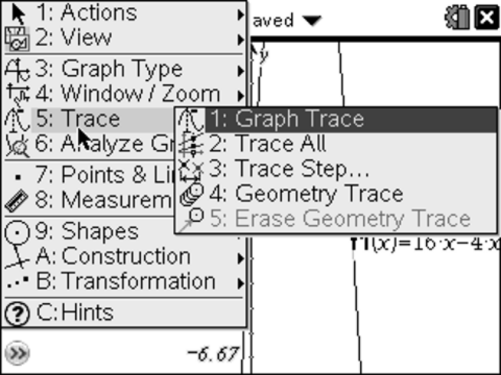

Therefore the times at which the ball is on the ground are :

__________________________________________________________________________

 | Method 2 – By simply using ‘solve’ in the calculator
(follow the instruction on the CAS calculator)

- Go the calculator section of TI
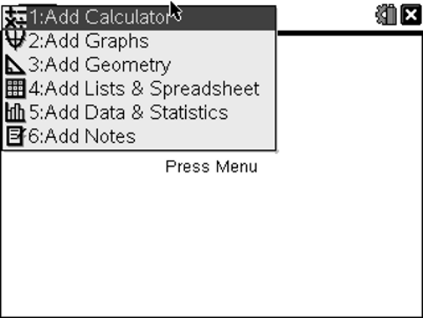

- Go to Menu, Algebra and then solve
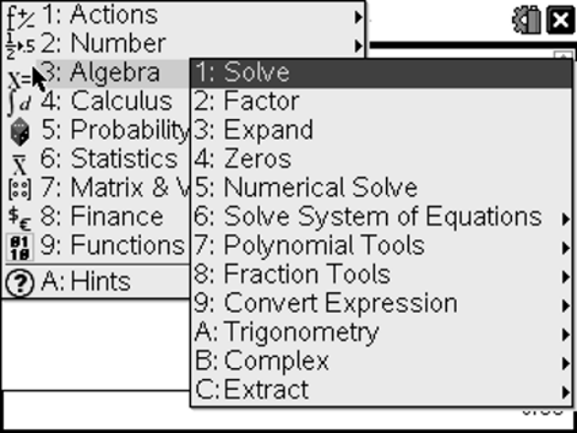

- Type the equation and solve for x. Press enter.
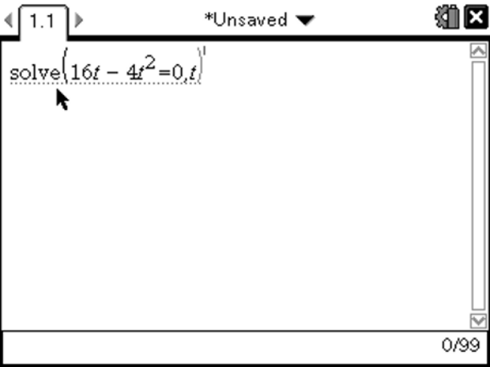

Write the answers below:
__________________________________________________________________________
Task 5 | Optimisation  Optimisation is a process of obtaining the optimum or the best solution to a practical problem by finding maximum or minimum values.
The perimeter of a rectangle is 140 cm. Find what length and width will give the maximum area.
[6 marks: 1, 1, 1, 1, 1, 1]
- Draw a rectangle and label the length as ‘x’ and width as ‘y’

- Write an equation of perimeter using the information provided.

- Rearrange the above equation in terms of y. Mark it as equation 1.

(In order to rearrange, use ‘solve’ function on the CAS as shown below)

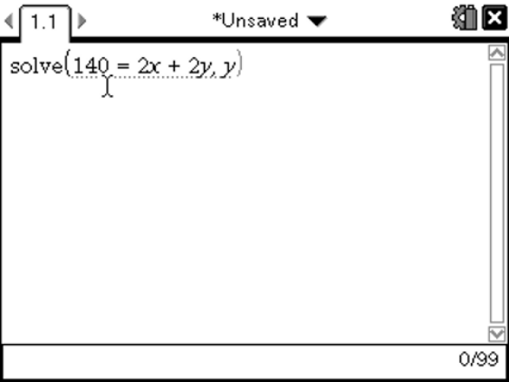

Press enter

- Write the area formula in terms of x and y.

- Replace y from equation 1 in the area formula

- After expanding the brackets, you should be able to get the following equation

Area = 70x - x²

- Use Graph in the CAS calculator and get the graph for above equation.
- Go to menu, trace and then graph trace. Move the cursor to the highest point of the parabola.

- Write the answer for maximum area below.

